**Amber Class Homework Autumn 2 week 4**

Homework due: Tuesday 3rd December 2024

|  |
| --- |
| **Reading: Daily for 30 minutes, write up in your Reading Record with a comment about what was read/discussed.**  **Spelling: see below**  **Times tables: log on to PurpleMash and under 2do’s your find multiplication quiz**    **Number bonds: log on to PurpleMash and under games you will find Bond Bubbles. Try this to help with your number bonds!** |

**Spellings:**

|  |  |  |
| --- | --- | --- |
| Group 1 | Group 2 | Group 3 |
| accident  answer  busy  believe  build  natural  mention  though | although  appear  arrive  length  group  often  heart  breath | kind  gold  whole  behind  water |

Use this space to practice your spellings!

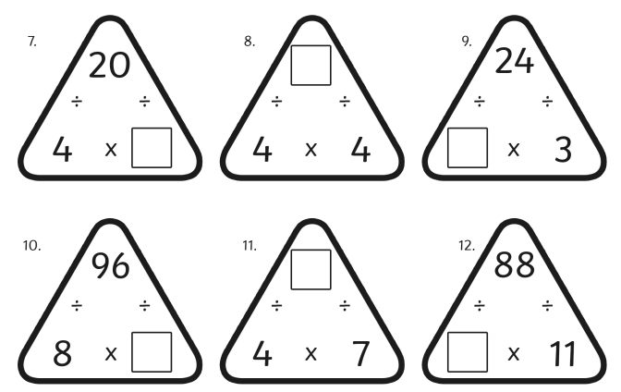 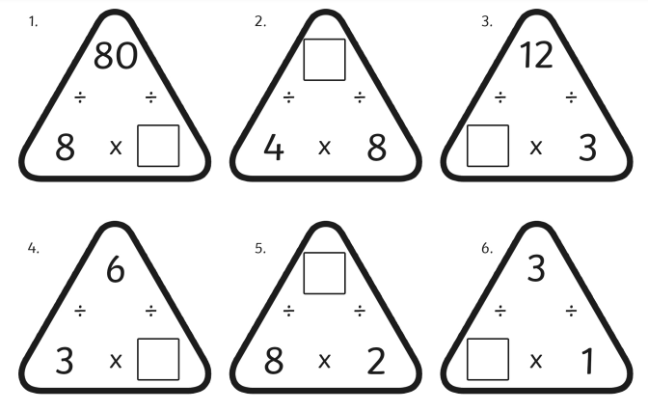

Complete the missing times table

Maths challenge:

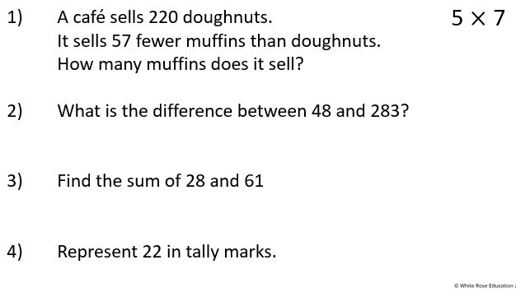

**English / DT:**

Write a recipe for chocolate you have made up. What flavours / ingredients are you going to use? (strawberry, Oreo). Remember recipe needs to have step by step instruction.

1

2

3

4

5

6

7

8

9

10