Ruby Class Homework Autumn 2 week 1
A
Homework due: Tuesday 12th November 2024
Next week we are learning:
Maths | Literacy | Science | RE
We will be starting our new unit ‘addition and subtraction’.  We will be looking at related facts, focusing on number bonds to 10, 20 and 100. | We will be looking at features of a recount. | We will be looking at identifying objects as living, dead and never alive. | We will be looking at the creation story in more depth and looking at what the story tells Christians about God.

Spellings:
Practise spellings ready for weekly spelling test- see below for your child’s spelling group – These groups are subject to change as they are based on their current spelling ages.

Reading:
Read every day for 15 minutes.
Please log this in Reading Records.
Children must write a small comment in their journals everyday about their book.

Maths: number bonds and related facts

Challenges are optional – although please have a go if you can.

Spellings:
Group 1 | Group 2 | Group 3
rain  wait  train  paid  afraid  oil  join  coin  soil  she | hunting  hunted  hunter  buzzing  buzzed  buzzer  jumping  jumped  jumper  cracker | wristband  wrinkle  wriggle  correct  terrible  current  landscape  compose  any  who

Maths:
Can you write these numerals as words?

101 _____________ 82 _____________

91 _______________ 47 ________________

185 ________________ 117 _______________

145 ________________ 220 _______________

Complete the number tracks.

- 6, 8, 10, 12, ___, 16, 18, ___, ___, 24
2. ___, 10, 12, ___, ___, 18, 20, 22, 24
3. 20, ___, 16, 14, ___, ___, 8, 6, 4, 2
4. ___, ___, 14, 12, 10, 8, 6, 4, ___, 0
5. 24, 22, 20, ___, 16, ___, 12, ___, ___
6. ___, 40, ___, 36, 34, 32, __, 28, ___

Complete the number sentences:

3 + 7 = 10
____ + 7 = 20

5 + 5 = 10
5 + ____ = 20
What pattern do you notice?

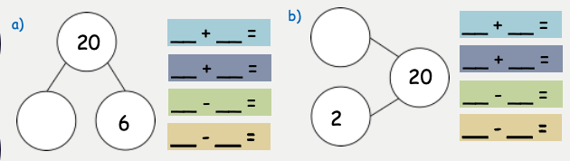
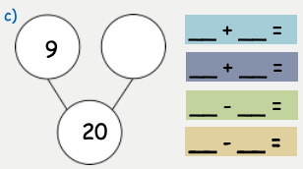
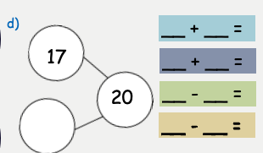
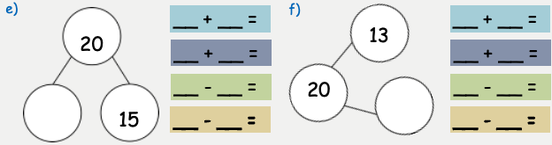
- 100 - _____ = 70
- 100 - _____ = 30
- 60 = 100 - _____
- 50 = 100 - _____
- 50 – 20 = _____
- 80 – 30 = _____
- _____ - 40 = 10

- 10 + 60 = ____
- _____ = 40 + 30
- 100 = 20 + _____
- 40 + _____ = 100
- 100 = 80 + _____
- 20 + _____ = 50
- 40 = 10 + _____

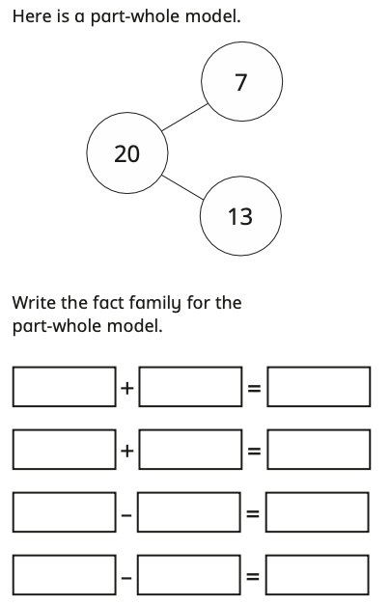

Challenges:
