**Emerald Class Homework Autumn 2 week 3 – Y4**

Homework due: Tuesday 26th November 2024

|  |  |  |  |
| --- | --- | --- | --- |
| **Next week we are learning:** | | | |
| Maths | Literacy | Science | RE |
| We will be continuing unit on Multiplication and division | We will be will be continuing our unit on creating a Biography | We will be continuing our topic on Earth and Space | We will be continuing our unit on Judaism and its links to Christianity |

|  |
| --- |
| Some Useful Websites  Nrich.maths.org - https://nrich.maths.org/  Coolmath-games.com - https://www.coolmathgames.com/  Woodlands Junior School - https://www.primaryhomeworkhelp.co.uk/  BBC Bitesize - https://www.bbc.co.uk/bitesize/primary  Counton.org - <https://count-on.co.uk/>  <https://www.topmarks.co.uk/>  Purple Mash also have some lovely Maths and spellings activities  Or use other websites/ways that you enjoy 😊.  ***Spellings:***  Practise spellings ready for weekly spelling test- see below for your child’s spelling group – These groups are subject to change as they are based on their current spelling ages.  ***Reading:***  Read every day for 30 minutes. Please log this in Reading Records.    ***Maths: Number based work - remember to use the inverse to help work out calculations***  ***Part + part = whole***  ***Whole – part = part***  ***English – year 4 SPaG – nouns and verbs***  ***Please complete both the reading and maths work*** |

Spellings: please can group 2 learn group 3 as well

|  |  |  |
| --- | --- | --- |
| **Group 1** | Group 2 | Group 3 – modal verbs |
| their  there  they’re  here  hear  because  people  saw  where  were | expression  discussion  confession  permission  admission  transmission possession  profession  depression  impression | can  could  may  might  must  shall  should  will  would  ought |

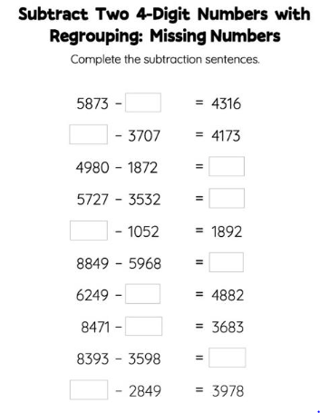

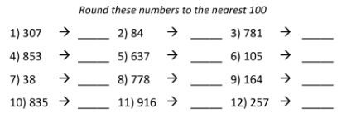

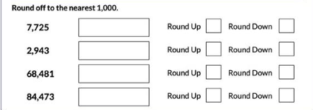

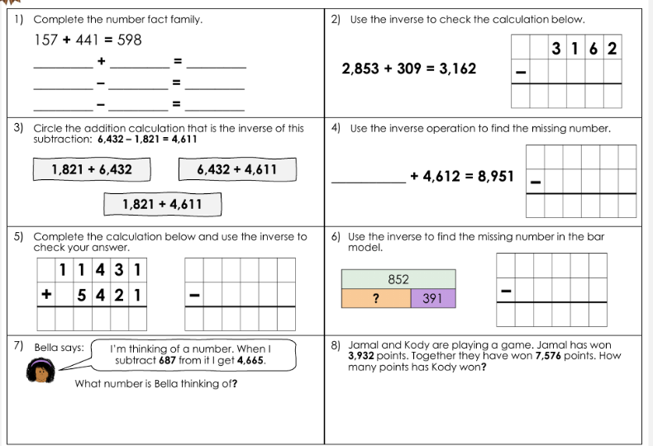

Optional challenges – nouns and verbs

