Ruby Class Homework Autumn 2 week 4
A

Homework due: Tuesday 3rd December 2024
Next week we are learning:
Maths | Literacy | Science | RE
We are looking at how we can add two-digit numbers together without crossing 10. | We will be looking elements of grammar. | We will be looking at microhabitats. | We will be looking at the meaning of Christmas symbols.

Spellings:
Practise spellings ready for weekly spelling test- see below for your child’s spelling group – These groups are subject to change as they are based on their current spelling ages.

Reading:
Read every day for 15 minutes.
Please log this in Reading Records.
Children must write a small comment in their journals everyday about their book.

Maths: Using number bonds to add efficiently.

SPaG: Identifying word classes.

Spellings:
Group 1 | Group 2
rain  train  book  look  car  star  soil  she  you  was | gem  giant  magic  giraffe  energy  jacket  charge  hedge  there  some

Maths:
Complete the number tracks.
- 26, 28, ___, ___, 34, 36, ___, 40
2. 50, ___, ___, 35, ___, 25, 20, 15
3. 60, ___, 56, ___, 52, 50, ___, 46
4. ___, ____, 60, 55, ____, ____, 40
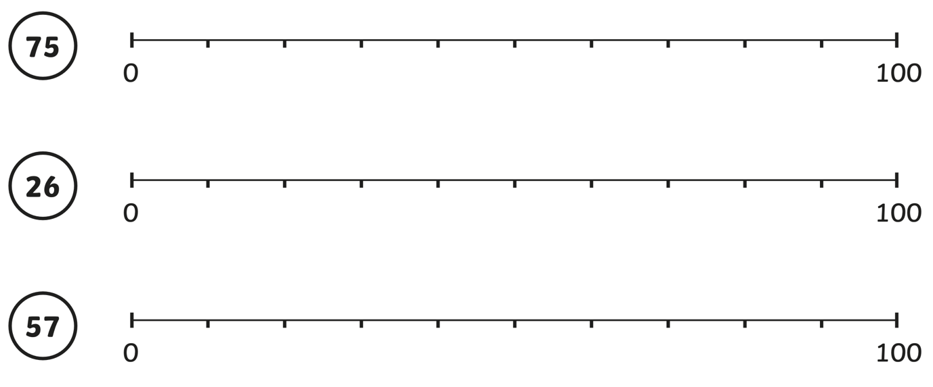
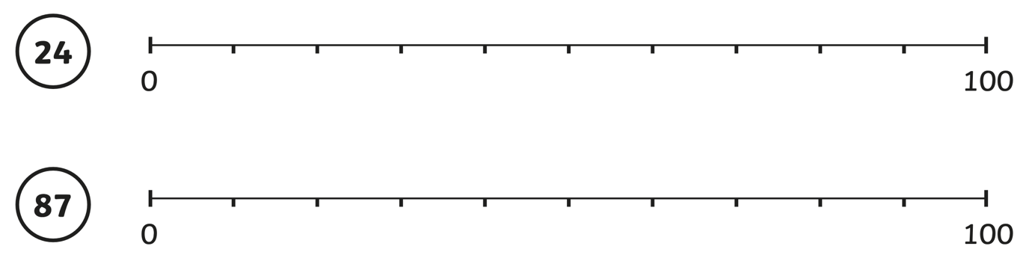

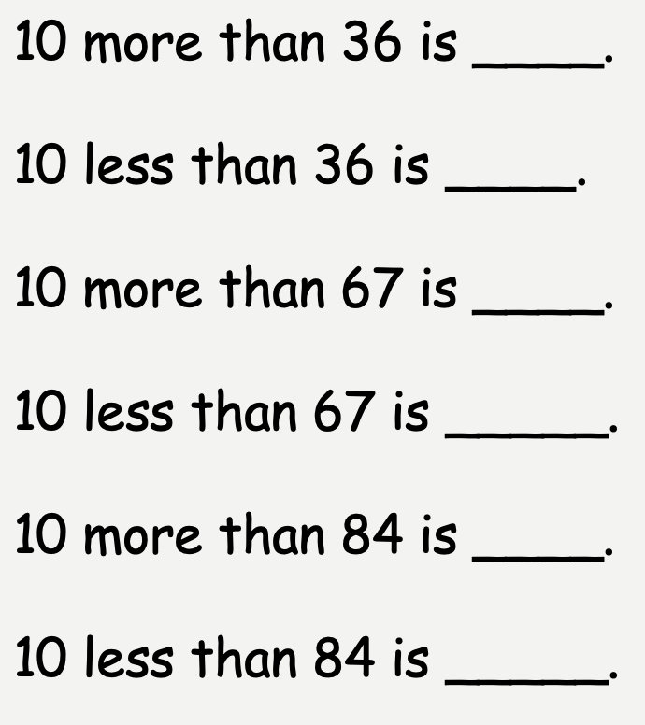
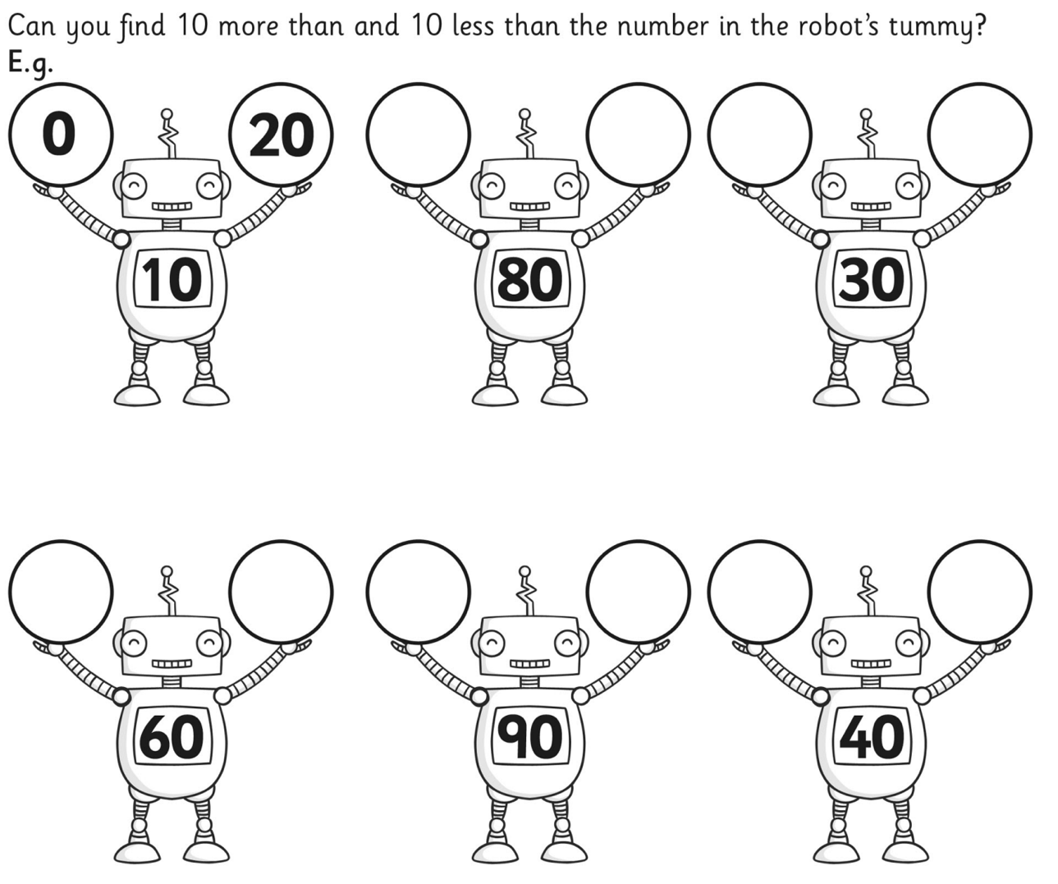

Calculate the following equations:

45 + 30 = 59 + 40 = 34+ 50 =
36- 20 = 78 – 60 = 92 – 10 =

= 70 + 18 = 50 + 23 = 69 – 60
= 67 – 30 = 86 -40 = 71 - 20
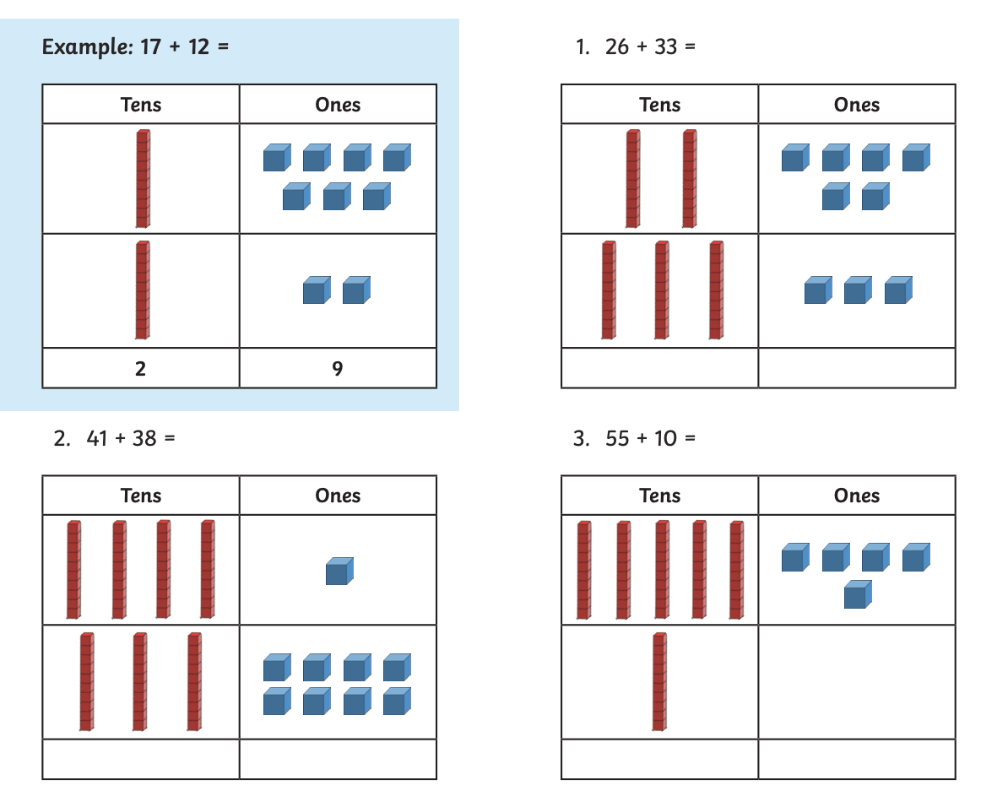
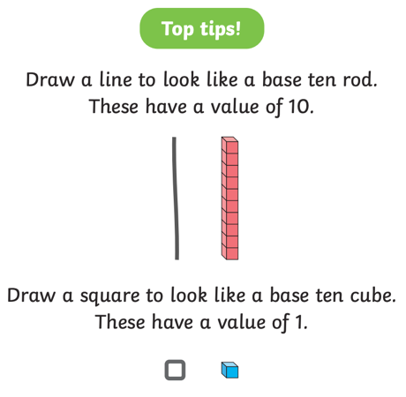

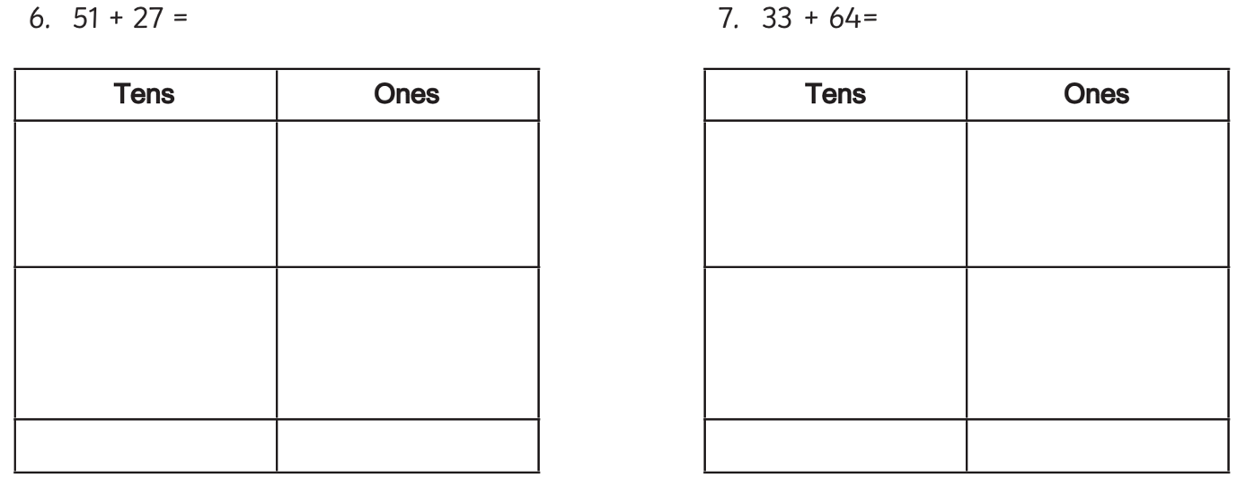
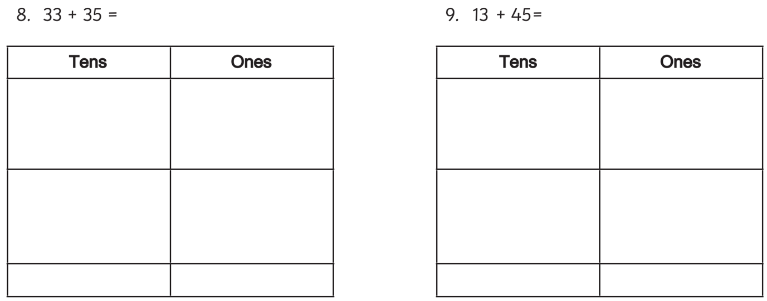
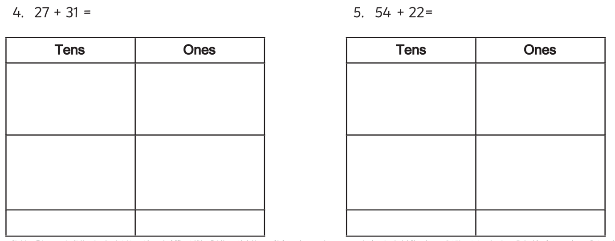
SPaG
Underline the nouns and circle the verbs in these sentences:
1. The fluffy white cat scratches the soft leather sofa furiously.

- A beautiful shiny fish swims gently in the pond.

- The shiny red car drives smoothly down the road.

Circle the noun:
grow
sparkle
shiny
tree

Circle the verb:
London
crawl
bird
sad

Circle the adjective:
bake
hop
hat
fluffy

