Ruby Class Homework Spring 1 week 1
A

Homework due: Tuesday 14th January 2025
Next week we are learning:
Maths | Literacy | Science | RE
We are looking at the properties of 2D and 3D shapes. | We are starting our unit on explanation texts, using the Great Fire of London for inspiration. | We will be looking at the properties of different materials. | We will be looking at Islam and the hoe Muslims belong to their faith family. We will be looking at the features of a mosque.

Spellings:
Practise spellings ready for weekly spelling test- see below for your child’s spelling group – These groups are subject to change as they are based on their current spelling ages.

Reading:
Read every day for 15 minutes.
Please log this in Reading Records.
Children must write a small comment in their journals everyday about their book.

Maths: Properties of 2D shapes.

SPaG: Identifying nouns, adjectives, and verbs.

Challenges: Sorting 2D shapes.
Improve the sentence.

Spellings:
Group 1 | Group 2
the  and  said  was  you  they  she  his  but  with | triangle  circle  square  octagon  hexagon  symmetry  many  busy  clothes  climb

Maths:
Complete the number tracks.
- 20, 18, ___, ___, 12, 10, ___
2. 3, ___, 9, ____, 15, 18, ____
3. ____, 6, ____, 12, 15, ____, _____
4. _____, _____, 21, _____, 27, 30, 33

Calculate these sums:
47 + 5 =

50 + 40 =

20 + 47 =

46 + 23 =

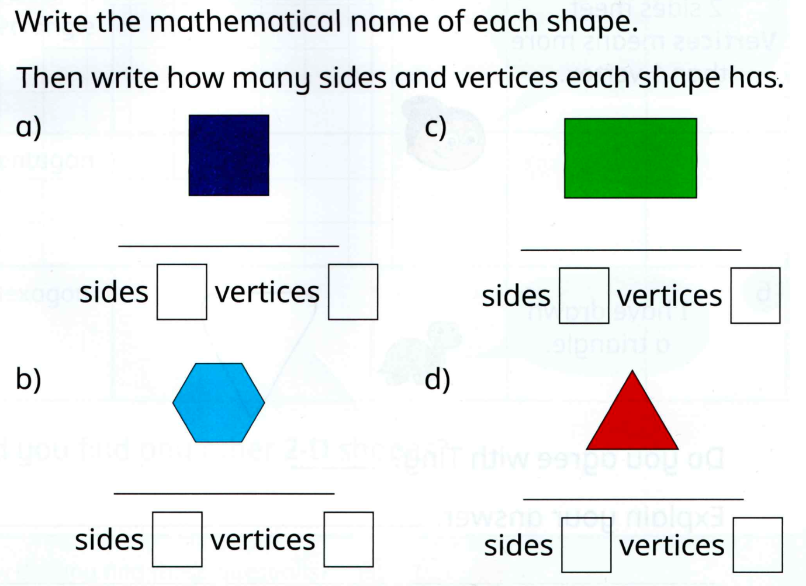
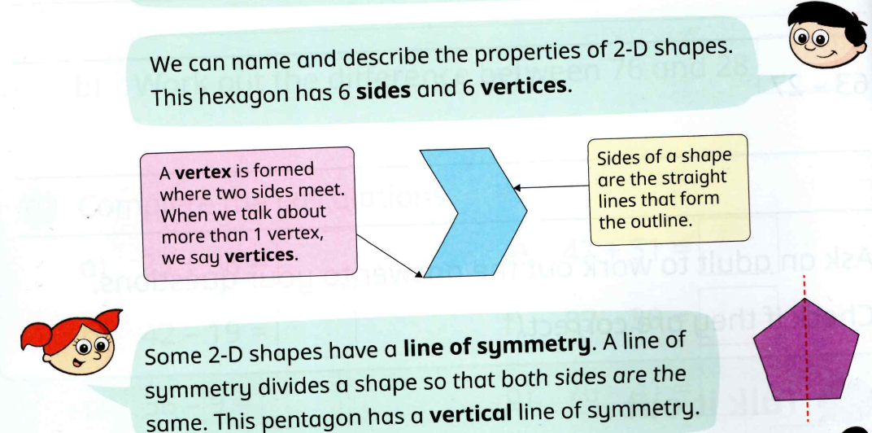

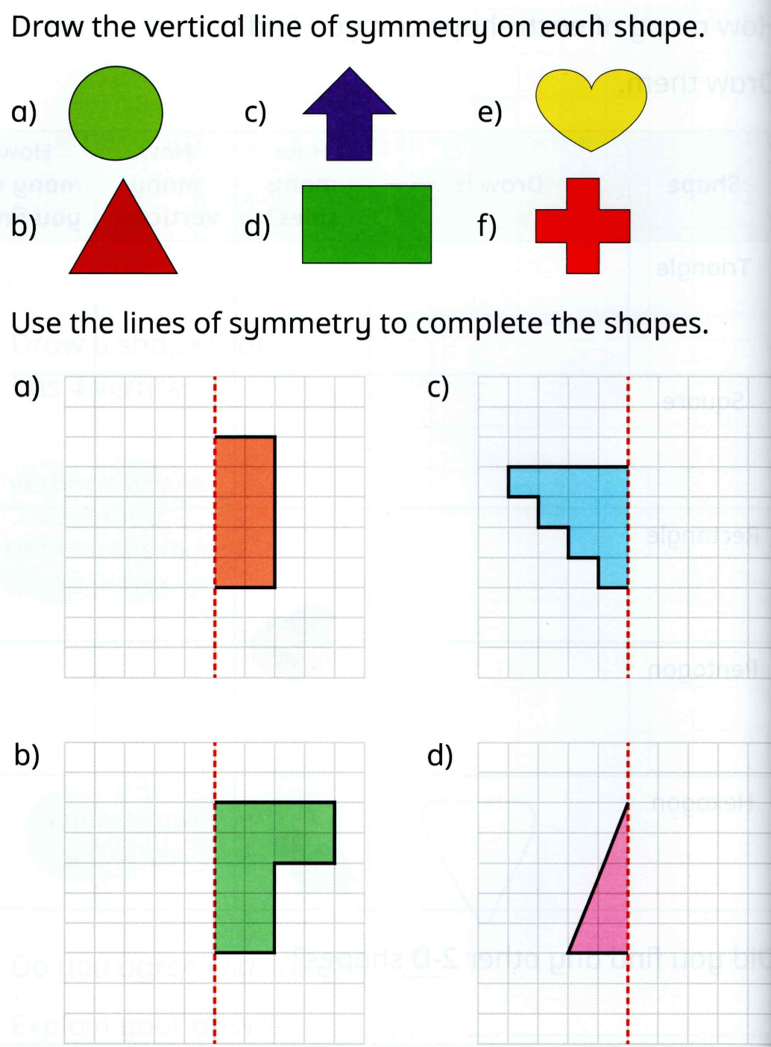
SPaG
Circle the adjective and underline the adverbs.

The fierce fire spread quickly through the crowded streets of London.

The devastating fire burned rapidly, destroying many homes in London.

Circle the noun:
slowly
fire
run
burn

Circle the adjective:
sprinkle
brick
wood
blazing

Circle the adverb:
Incredibly
jump
rush
river

Challenges

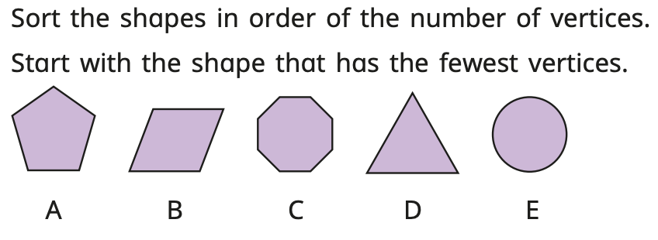

Can you carefully add interesting adjectives and adverbs to this sentence to make it more exciting?

The fire burned in London.

