Ruby Class Homework Spring 2 week 3
A

Homework due: Tuesday 18th March 2025
Next week we are learning:

Maths | Literacy | Science | RE
We will be looking at division. We will be learning about two different methods: grouping and sharing. | We will be learning about poetry.  We will be looking at rhyming schemes and similes. | We will be celebrating science week with the theme adapt and change. | We will be looking at the theme of salvation in Christianity. This week we will be exploring the significance of the Easter story.

Spellings:
Practise spellings ready for weekly spelling test- see below for your child’s spelling group – These groups are subject to change as they are based on their current spelling ages.

Reading:
Read every day for 15 minutes.
Please log this in Reading Records.
Children must write a small comment in their journals everyday about their book.

Maths: grouping and sharing

SPaG: Correcting punctuation accurately.

Challenge (optional): Improve the sentence

Spellings:
Group 1 | Group 2
put  some  come  one  two | their  there  they’re  hopeful  hopeless  careful  careless  helpful  helpless

look | say | cover | write | check
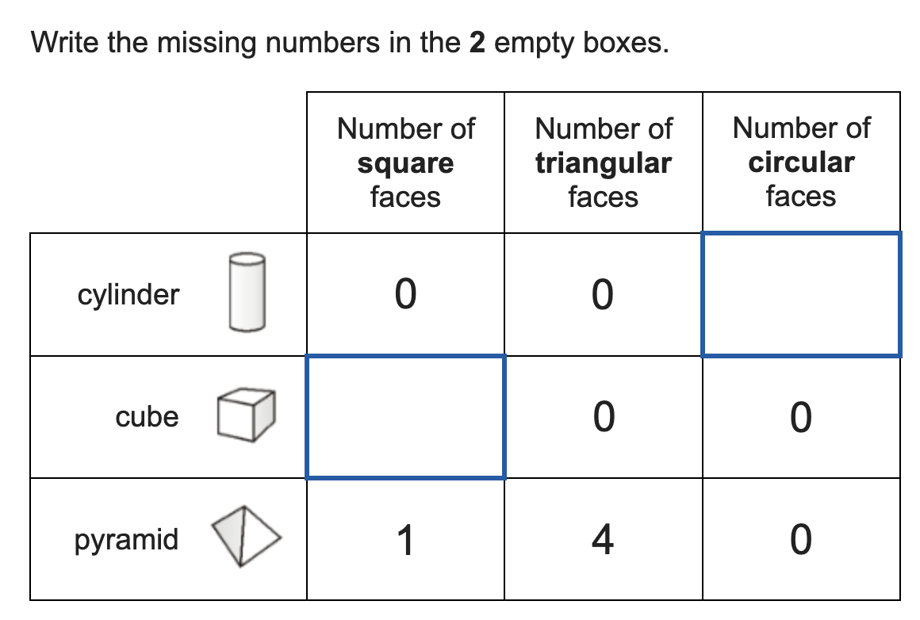
Maths:

1. ____ = 34 + 24  2. ____ = 47 + 25  3. 78 – 34 = ____  4. 64 – 23 = ____  5. 52 – 18 = ____ | 6. 9 x 2 = ____  7. 6 x 2 = ____  8. 10 x 2 = ____  9. 2 x 3 = ____  10. 8 x 1 = ____
Solve the equations:
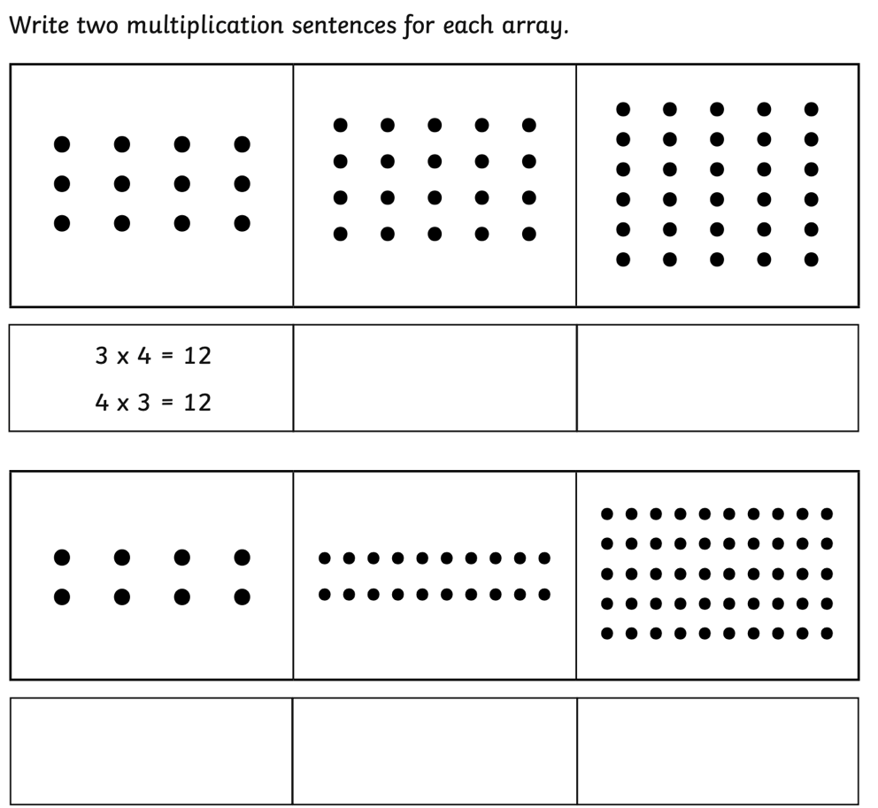
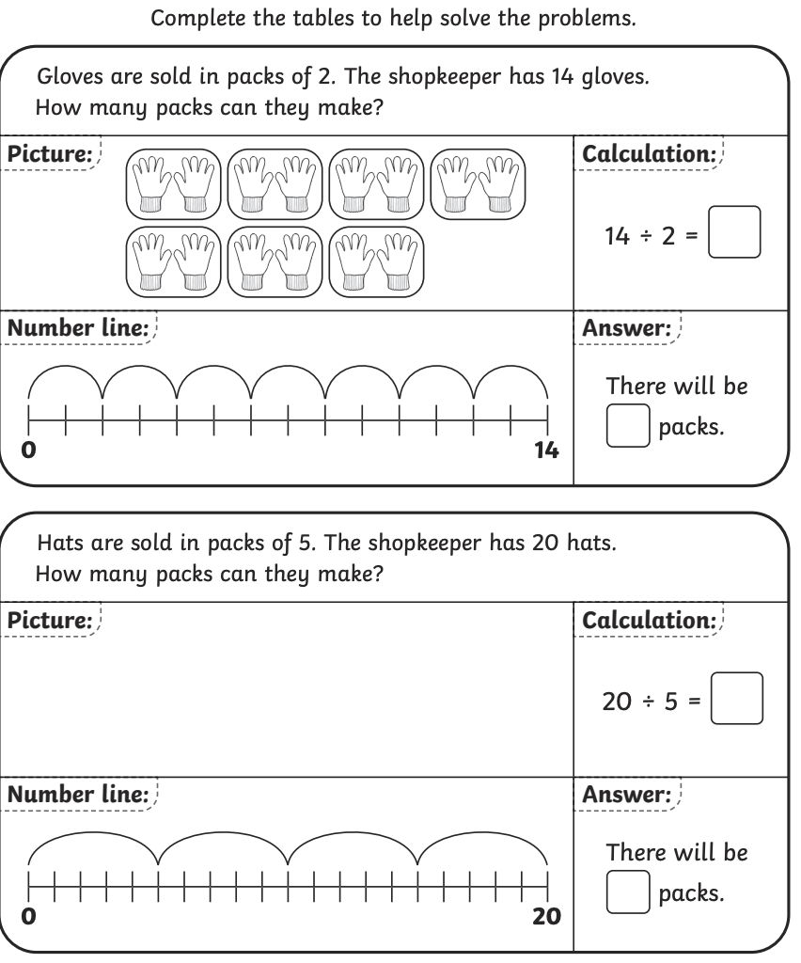

SPaG
Rewrite the sentences below with the correct punctuation.

1. the monsters roar could be heard for miles

2. where did the horrifying beast come from

3. what a terrible monster

4. billy rescued the rabbits from the monster soup

Challenges:
SPaG
Improve the sentence by adding an adverb and two adjectives.

The monster crept through the door.

Maths
