**Emerald Class Homework Spring 2 week 3 – Y4**

Homework due: Tuesday 18th March 25

|  |  |  |  |
| --- | --- | --- | --- |
| **Next week we are learning:** | | | |
| Maths | Literacy | Science | RE |
| We will be continuing our unit on Fractions | We will be will be working on some elements of SPaG and writing some poems | We will be our unit on continuing our Living things and habitats | We will be continuing our unit on Salvation |

|  |
| --- |
| Some Useful Websites:  Nrich.maths.org - https://nrich.maths.org/  Coolmath-games.com - https://www.coolmathgames.com/  Woodlands Junior School - https://www.primaryhomeworkhelp.co.uk/  BBC Bitesize - https://www.bbc.co.uk/bitesize/primary  Counton.org - <https://count-on.co.uk/>  <https://www.topmarks.co.uk/>  <https://www.tomscott.com/usvsth3m/maths/>  Purple Mash also have some lovely Maths and spellings activities  Or use other websites/ways that you enjoy 😊.  ***Spellings:***  Practise spellings ready for weekly spelling test- see below for your child’s spelling group – These groups are subject to change as they are based on their current spelling ages.  ***Reading:***  Read every day for 30 minutes. Please log this in Reading Records.    ***Maths – Fractions - improper to mixed number fractions and adding and subtracting with the same denominator***  ***English – pronouns*** |

Spellings:

|  |  |  |
| --- | --- | --- |
| **group 1 -**  homophones and near homophones | group 2- | group 3 – |
| grate  great  grown  groan  plain  plane  peace  piece  rain  reign  battle  survived | girls’  boys’  babies’  parents’  teachers’  women’s  men’s  children’s  people’s  mice’s    Reign  corset | forty  scorch  absorb  decorate  afford  enormous category  tornado according opportunity  protestant  execute |

Please write your spellings in sentences to show a correct understanding of the words

………………………………………………………………………………………………………………………………………………………………………………………………………………………………………………………………………………………………………………………………………………………………………………………………………………………………………………………………………………………………………………………………………………………………………………………………………………………………………………………………………………………………………………………………………………………………………………………………………………………………………………………………………………………………………………

Remember what stays the same

As an added challenge when your fraction becomes an improper fraction (which is bigger numerator than denominator) turn it in to a mixed number fraction

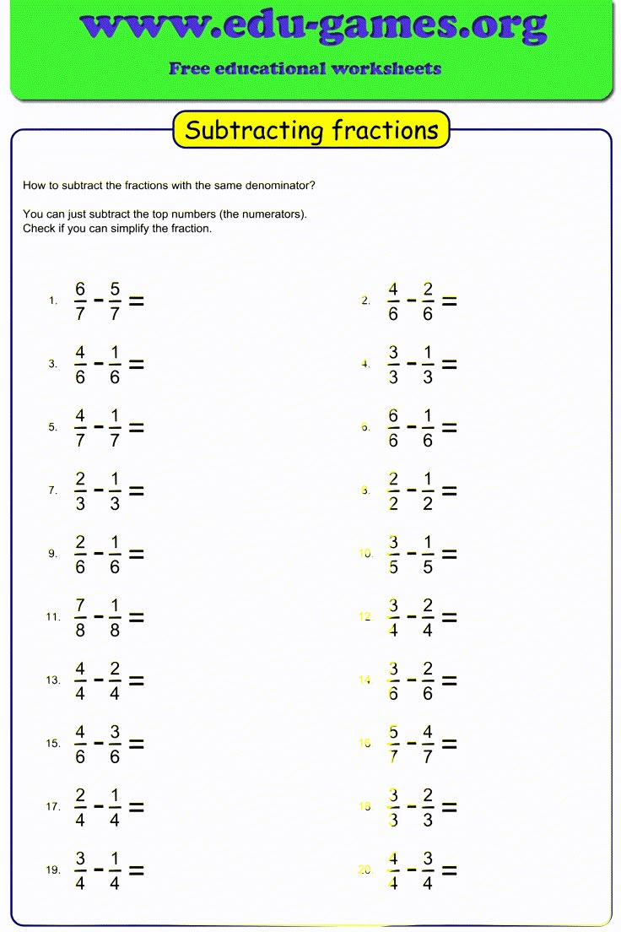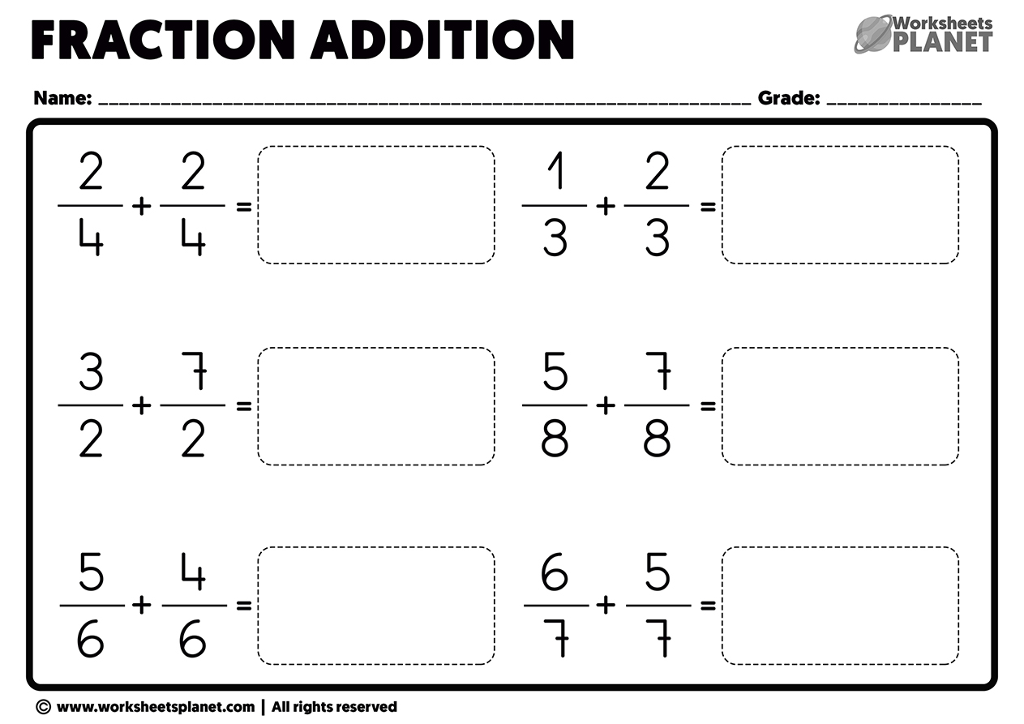

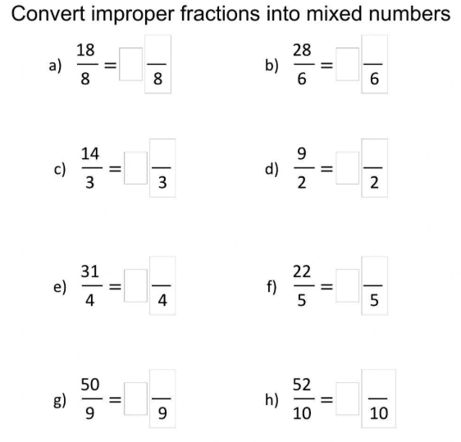

Remember in order to convert you need to use your knowledge of multiplication and division to help identify the whole numbers. For example a) there are 2 lots of 8 in 18 which 2 remaining, which then becomes

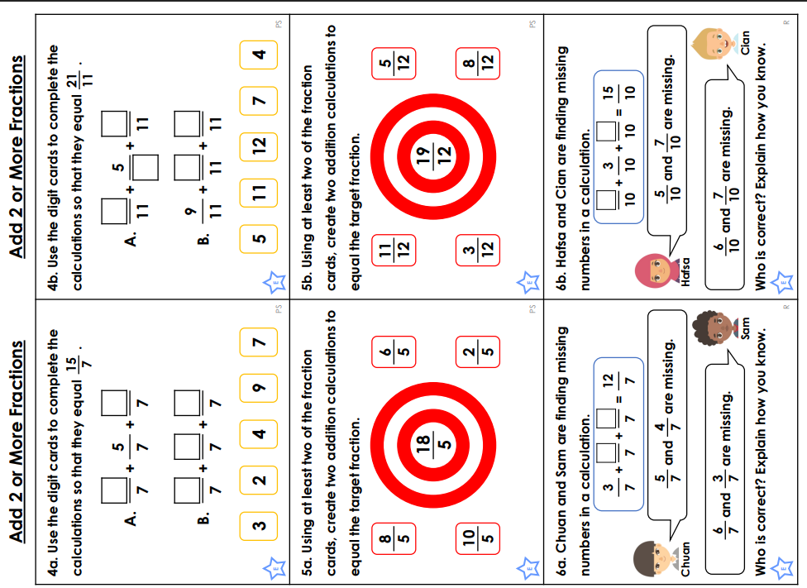

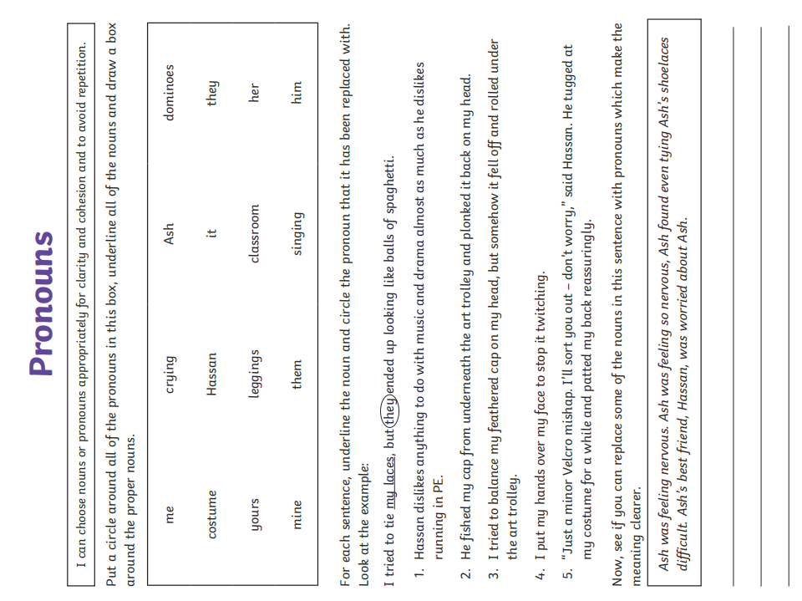

Challenge – optional