**Amber Class Homework Spring term 1 week 5**

Homework due: Tuesday 11th February 2025

|  |
| --- |
| **Reading: Daily for 30 minutes, write up in your Reading Record with a comment about what was read/discussed.**  **Spelling: see below**  **Dividers:**  Complete the dividers game on 2do (purple mash)  **English – Topmark’s suffixes**  <https://www.spellingplay.co.uk/planning-and-resources/year-2/vowel-suffixes/violets-vowel-suffixes> |

**Spellings:**

|  |  |  |
| --- | --- | --- |
| Group 1 | Group 2 | Group 3 |
| extreme  certain  February  straight  continue  sentence  reign  possess | material  thought  decide  guard  century  actual  heart  opposite | again  money  after  everybody  prove |

Use this space to practice your spellings!

**Complete the math’s activities -**

Can I have the measurements of the lines in centimeters please.

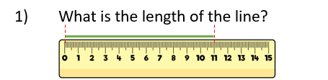

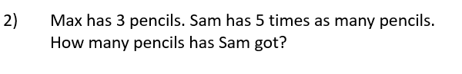

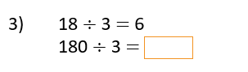

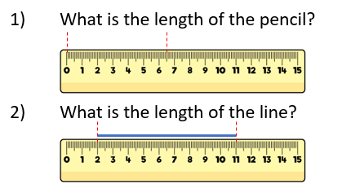

**Maths challenge:**

Show your workings below:

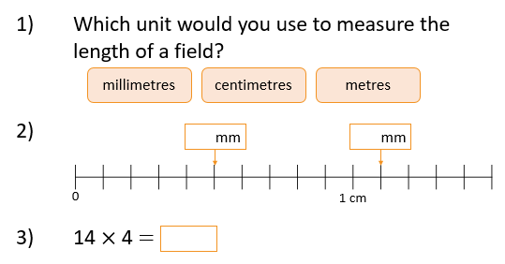

**English:** Answer the comprehension questions – underline the parts in the text to help you.

1. What did they do with the food once they caught it?
2. What did the echidna tell the turtle to do?
3. Who stayed at home?
4. Why was the turtle hungry?
5. How do you think turtle felt being on his own? Why?

Challenge: Predict what you think might happen next.

