**Amber Class Homework Spring term 1 week 1**

Homework due: Tuesday 14th January 2025

|  |
| --- |
| **Reading: Daily for 30 minutes, write up in your Reading Record with a comment about what was read/discussed.**  **Spelling: see below**  **Times tables: log on to PurpleMash and under 2do’s your find multiplication quiz**    **Number bonds: log on to PurpleMash and under games you will find Bond Bubbles. Try this to help with your number bonds!** |

**Spellings:**

|  |  |  |
| --- | --- | --- |
| Group 1 | Group 2 | Group 3 |
| business  bicycle  imagine  possession  quarter  various  thought  occasionally | notice  library  forwards  often  early  answer  potatoes  build | pretty  should  only  would  every |

Use this space to practice your spellings!

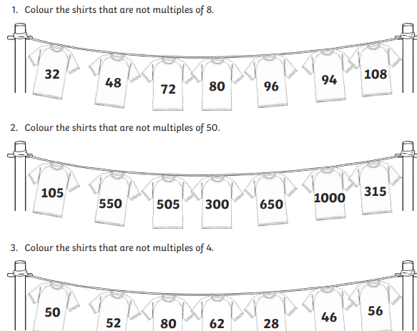

Complete the maths activities below.

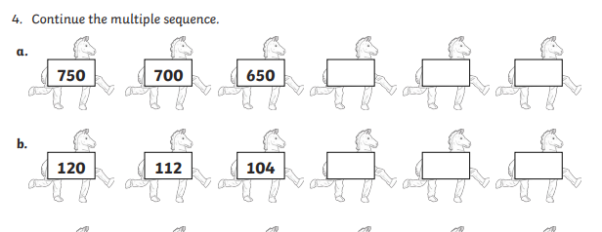

Maths challenge:

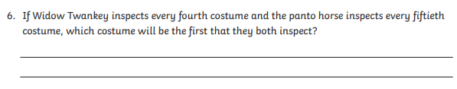

**English**

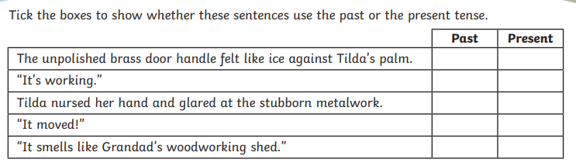Complete the past and present tense from this Roman book:

