**Amber Class Homework Spring term 1 week 2**

Homework due: Tuesday 21st January 2025

|  |
| --- |
| **Reading: Daily for 30 minutes, write up in your Reading Record with a comment about what was read/discussed.**  **Spelling: see below**  **Times tables:** [**https://www.timestables.co.uk/**](https://www.timestables.co.uk/) **Look at the game and complete the 7 times table – record score below**    **Times tables games:** [**https://www.topmarks.co.uk/times-tables/coconut-multiples**](https://www.topmarks.co.uk/times-tables/coconut-multiples) |

**Spellings:**

|  |  |  |
| --- | --- | --- |
| Group 1 | Group 2 | Group 3 |
| disappear  grammar  breath  consider  surprise  thought  various  occasionally | century  answer  material  often  regular  eight  group  fruit | who  most  even  great  improve |

Use this space to practice your spellings!

Complete the maths activities below.

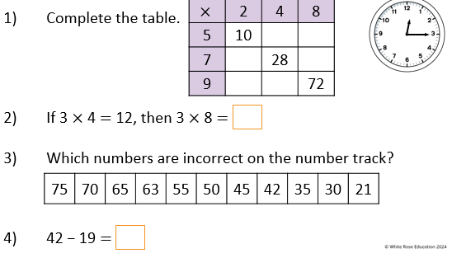

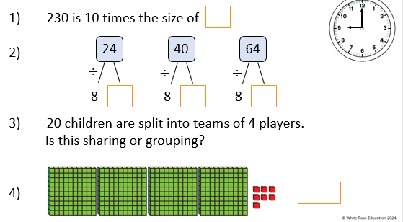

Maths challenge:

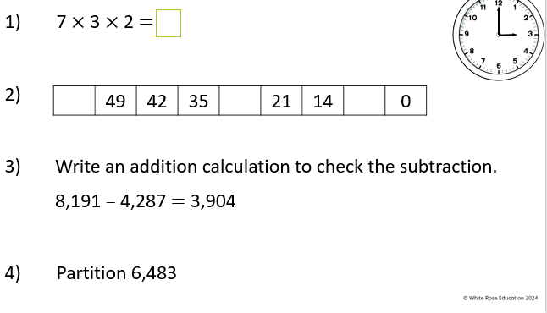

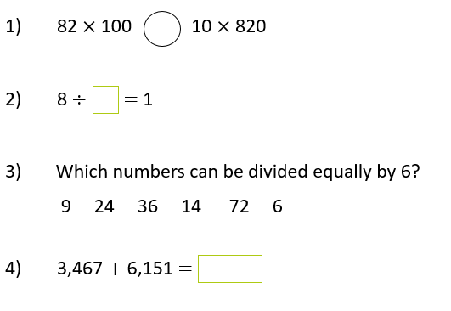

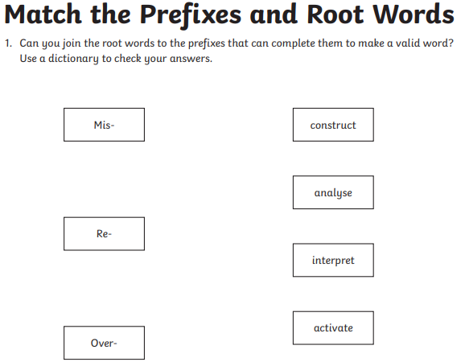**English**

**Challenge:** Put these words into sentences below

_____________________________________________________________

_____________________________________________________________

_____________________________________________________________

_____________________________________________________________

_____________________________________________________________

_____________________________________________________________

