**Amber Class Homework Spring term 1 week 3**

Homework due: Tuesday 28th January 2025

|  |
| --- |
| **Reading: Daily for 30 minutes, write up in your Reading Record with a comment about what was read/discussed.**  **Spelling: see below**  **Dividers:**  Complete the dividers game on 2do (purple mash)  **Times tables games:** [**https://www.topmarks.co.uk/times-tables/coconut-multiples**](https://www.topmarks.co.uk/times-tables/coconut-multiples) |

**Spellings:**

|  |  |  |
| --- | --- | --- |
| Group 1 | Group 2 | Group 3 |
| consider  history  favourite  different  remember  business  special  knowledge | appear  although  pressure  woman  early  heard  eight  often | because  could  every  break  kind |

Use this space to practice your spellings!

Complete the maths activities below.

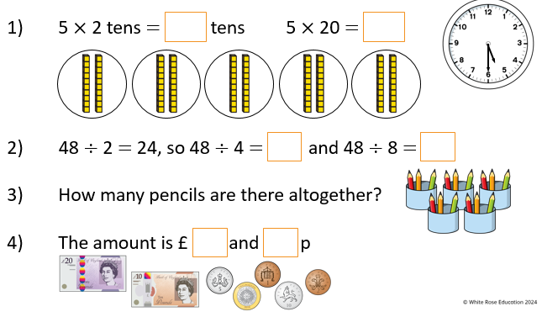

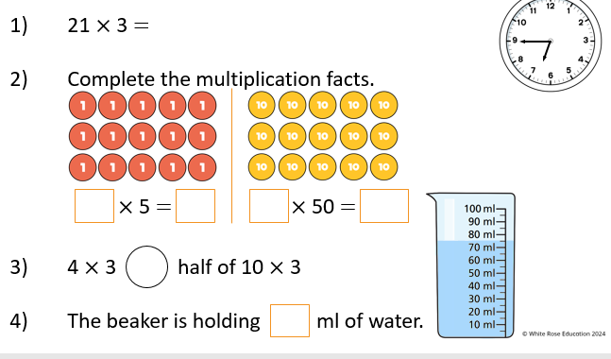

Maths challenge:

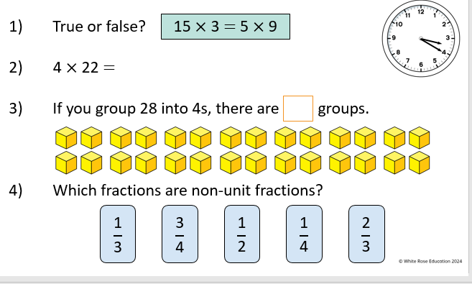

**English**

**English / History:**

Research facts on the Romans and write fact file below or on purple mash. In your 2do’s on purple mash I have put some Roman facts to read.

_____________________________________________________________

_____________________________________________________________

_____________________________________________________________

_____________________________________________________________

_____________________________________________________________

_____________________________________________________________