Topaz Reception Homework
Week 1 – 27th February 2025
Welcome back everyone. I hope that you all had a fabulous half-term and that the children are well rested and ready for another busy six weeks ahead!

Maths
In class this week we have been learning how numbers can be represented in many different ways (concrete, pictorial and abstract) Example:
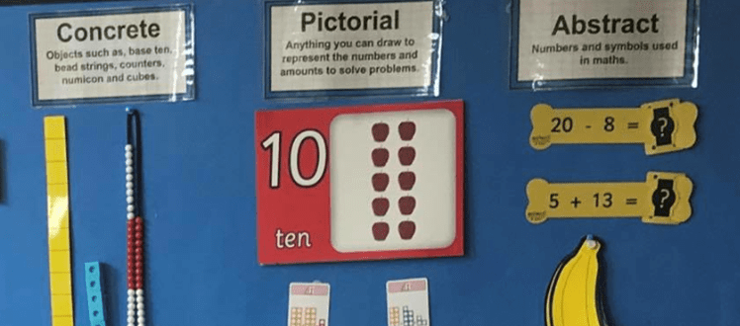
For their homework I would like the children to practice representing number in concrete and pictorial ways e.g. ask your child to represent the number 5 by drawing stars (pictorial) and by using objects e.g. Lego, buttons, cars etc (concrete) Repeat this activity with number between 0-10. Doing this regularly will help your child to embed their understanding of the value of number.

Phonics
We are continuing to recognise and read new sets of tricky words. For their homework for the next two weeks I would like the children to practice their new tricky word flashcards. Please cut them up and add them to the previous sets and practice for 5-10 minutes every day. As always, once your child is confident ready these words, please do encourage them to learn how to spell/write them. This really helps with the fluency when writing.
Your child also has a new set of phonics (phoneme/digraph) flashcards. As with the tricky word flashcards please encourage your child to practice these daily.

Reading
Your child will continue to bring home their Little Wandle Phonics book and their sharing book. When reading together please encourage your child to spot familiar graphemes and the new alternative spelling digraphs. It is also important to continue to develop their comprehension skills by answering questions about the text. Please do comment in their reading record every time you listen to your child read, or share a story together.

Please remember to return all books on Monday so they can be used during group teaching reading sessions. Many thanks for your support with this.
As always, if you have any questions regarding the homework, please do not hesitate to contact me via the school office.
Many thanks,

Mrs Allan

Next week in class we will be learning
Reading/Phonics – introducing new digraphs and trigraphs
Recap tricky words, introduce new tricky words
Writing –diary writing – focusing on applying phonic knowledge
Maths – Number – representing number/ comparing two amounts
R.E. – Bible Stories – Salvation (The Easter Story)– why is the cross important to Christians?
Art/RE – Palm Sunday Jesus journey Geography/Science- rainforests scenes (deforestation)
Physical Development – Gymnastics and Invasion Games
Book focus of the week: Bible – The Easter Story – Palm Sunday

