Topaz Reception – Homework 13th March 2025

Read Together Quick Read Comprehension

With your grown up, read the information below by sounding out and blending the words back together and then have a go at answering the questions.

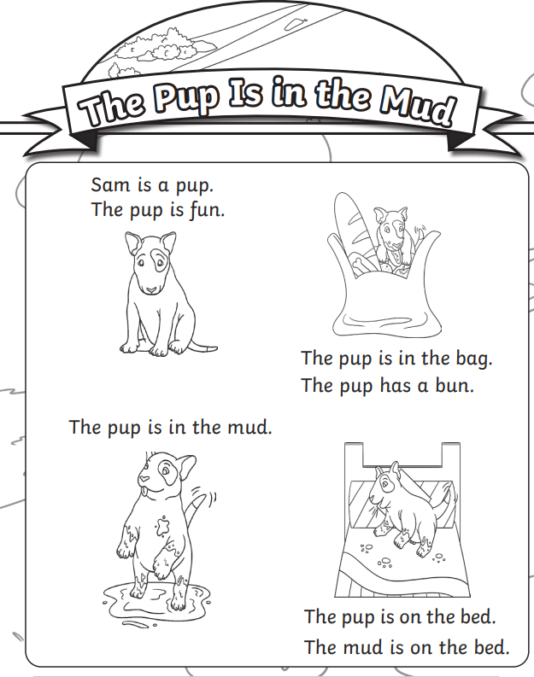

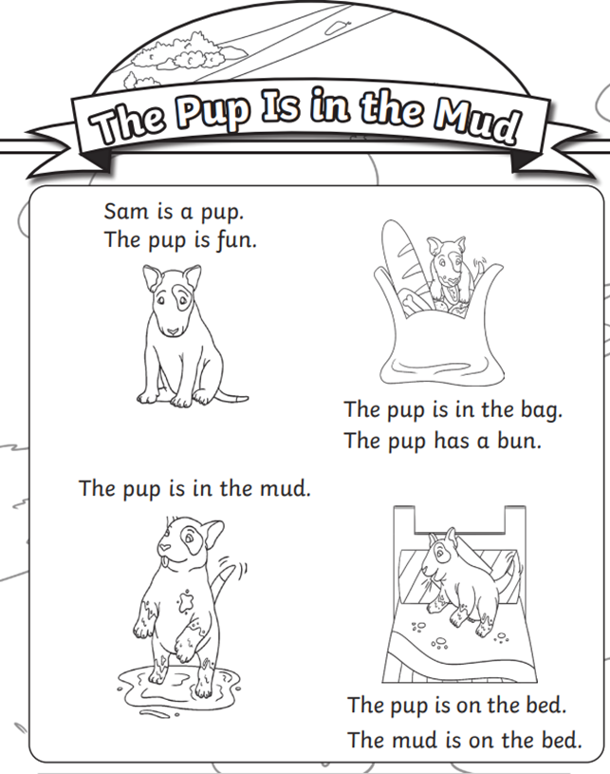

Challenge: you find a mnemonic to help remember the order of the colours of the rainbow, for example: *"****Rinse Out Your Granny's Boots In Vinegar****”* or you could even have a go at making up your own. Write your mnemonic below:

Challenge: draw a picture below of what you think the pups next adventure will be. Have a go at writing a sentence to go with your picture.

